2026年CSC奖学金博士生延期学生表格填写指南与成绩单
Guidance for PhD students to fill out form for 2026 CSC Extension and Transcripts

- 参评学生通过CSC号登录至信息系统
https://studyinchina.csc.edu.cn
Participating students log in to the system through CSC number
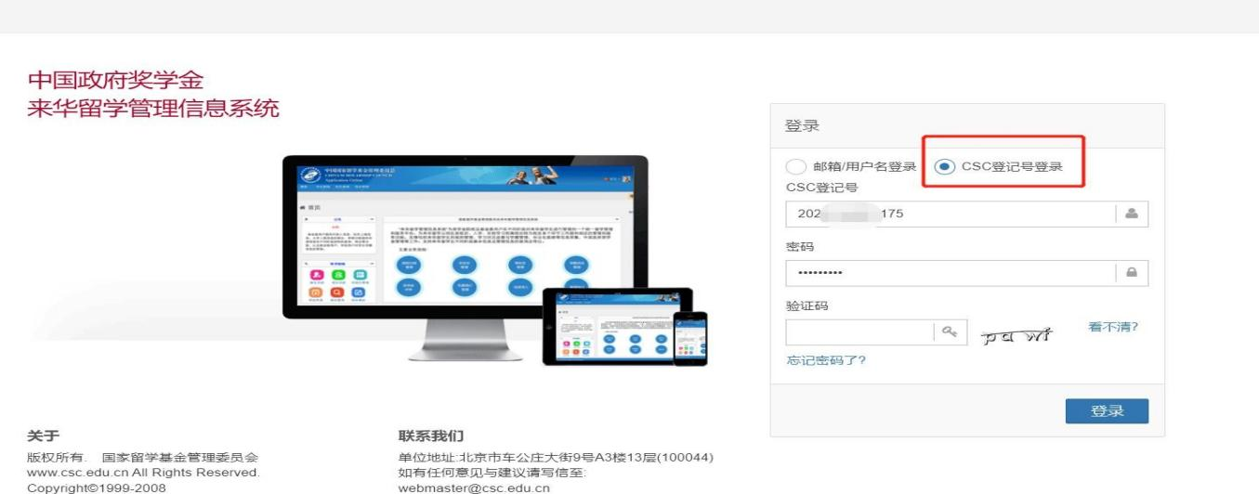
- 申请延期学生选择“博士生延期申请”,填写相关内容，点击“提交”。
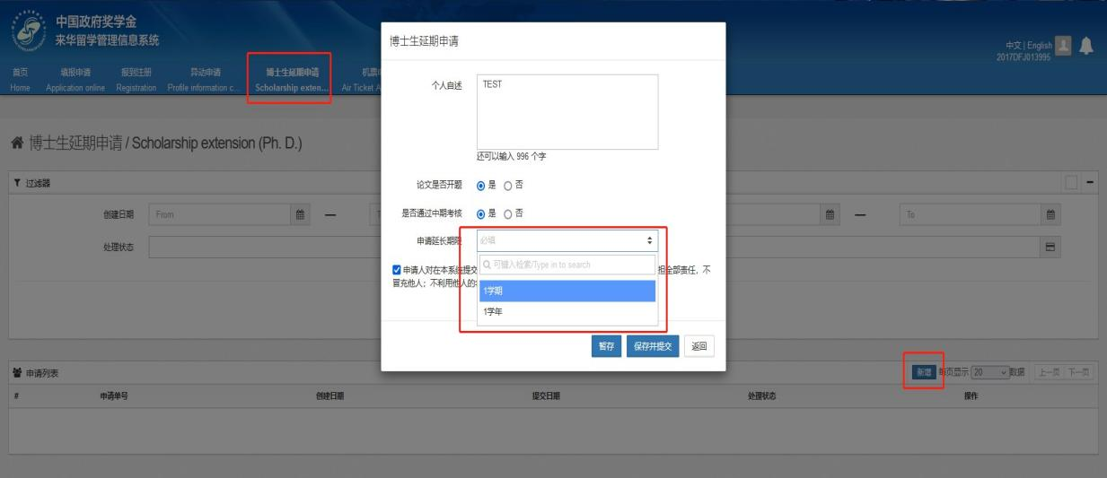
Participating students choose "Scholarship Extension Application for PhD students"，fill in the relevant information as required, and click "Submit"

3. 成绩单Transcripts
所有成绩单须中文版。Chinese version required for all.
博士可联系国际教育学院打印成绩单，须包含学号、学生姓名、要求学分、已修学分、未修学分。
PhD candidates shall print official transcripts (shall include student ID, student name, required credits, credits attained and average score) with School of International Education.

