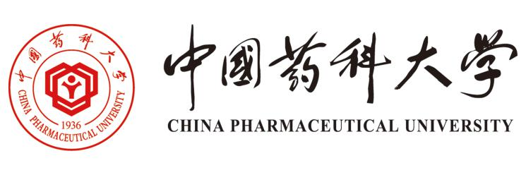
School of International Education
China Pharmaceutical University
# 639 Longmian Avenue, Jiangning District, Nanjing, P. R. China, 211198
Tel/Fax:0086-25-8618-5423
Email: admission@cpu.edu.cn
Website: international.cpu.cn

China Pharmaceutical University

2022 Master Programs
China Pharmaceutical University

About CPU
Founded in 1936, as China’s first independent four-year National College of Pharmacy, situated in the historical and cultural city of Nanjing;
One of the “211 project” key universities affiliated to the Ministry of Education of China, and listed among the “Double First-Class” universities in China;
CPU motto “Dedicated to academic excellence and devoted to public health.”
University Rankings
*National Discipline Evaluation: 2017 the 4th round, the pharmacy discipline was rated A+.
*US News World University Rankings: 2020 Pharmacology and Toxicology rank 18th in the world and 1st in Asia.
*ESI Ranking: 2021 Pharmacology and Toxicology ranked global top 1‰ (3 out of 10,000), 15th in the world and 1st in China.
*CWUR: Medicinal Chemistry has been ranked 3rd in the world for three consecutive years.

