2024年CSC奖学金博士生延期学生表格填写指南与成绩单
Guidance for PhD students to fill out form for 2024 CSC Extension and Transcripts

- 参评学生通过CSC号登录至信息系统
https://studyinchina.csc.edu.cn
Participating students log in to the system through CSC number
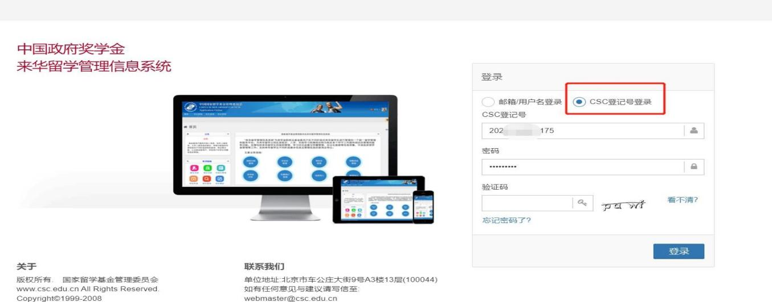
- 申请延期学生选择“博士生延期申请”,填写相关内容，点击“提交”。
Participating students choose "Scholarship Extension Application for PhD students"，fill in the relevant information as required, and click "Submit"

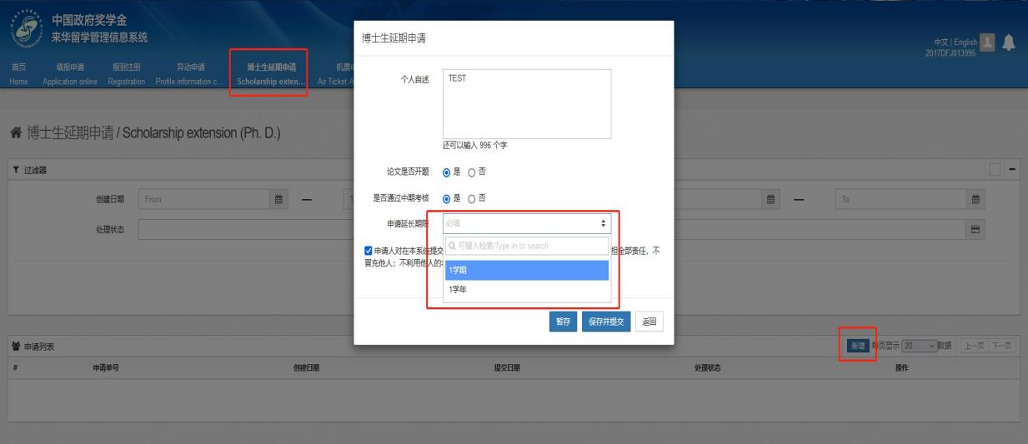
3.成绩单Transcripts
所有成绩单须中文版。Chinese version required for all.
博士可找研究生院（行政楼703）打印成绩单，或登录研究生院系统，将完整成绩单截图，须包含要求学分、已修学分、未修学分。见图例。
PhD candidates shall print official transcripts with Graduate School (Room 703 Admin Building) or login Graduate School system to make a Screen Shot of the entire page (shall include required credits, credits attained and average score. See the following sample.
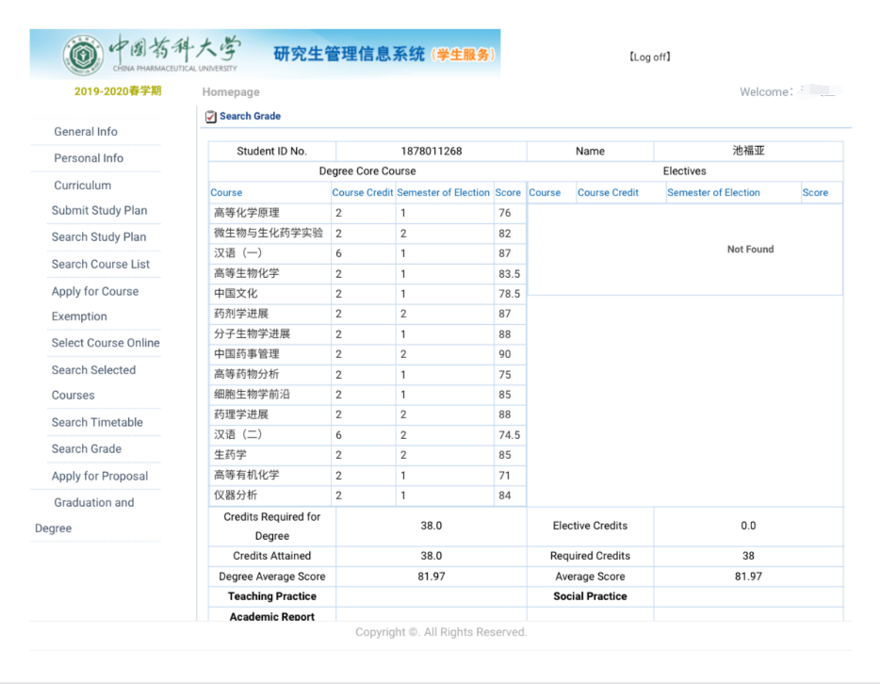研究生院信息系统生成成绩单示例
sample: transcripts generated by Graduate School online system

