2022年CSC奖学金年审学生表格填写指南与成绩单
Guidance for students to fill out forms for 2022 CSC Annual Review and Transcripts

- 参评学生通过CSC号登录至信息系统
https://studyinchina.csc.edu.cn
Participating students log in to the system through CSC number
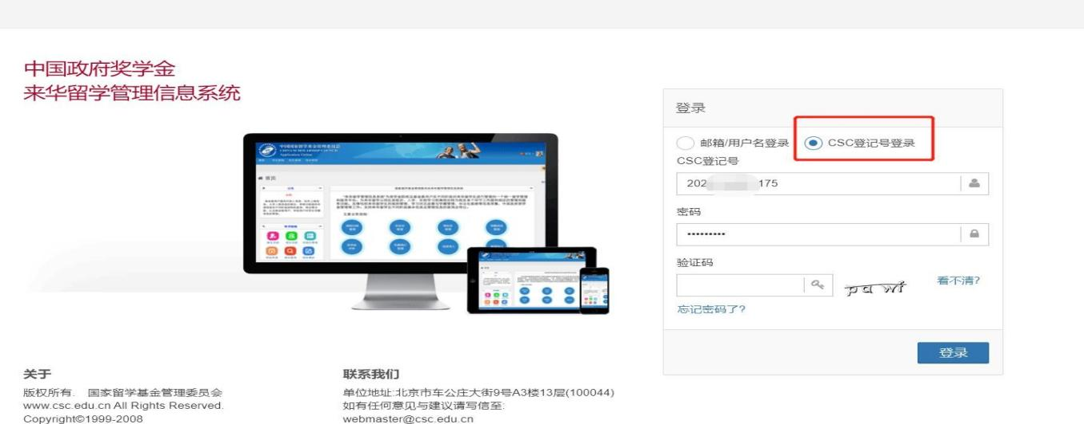
- 参评学生选择“奖学金年度自评”
Participating students choose "Annual Review of scholarship of Self-evaluation"
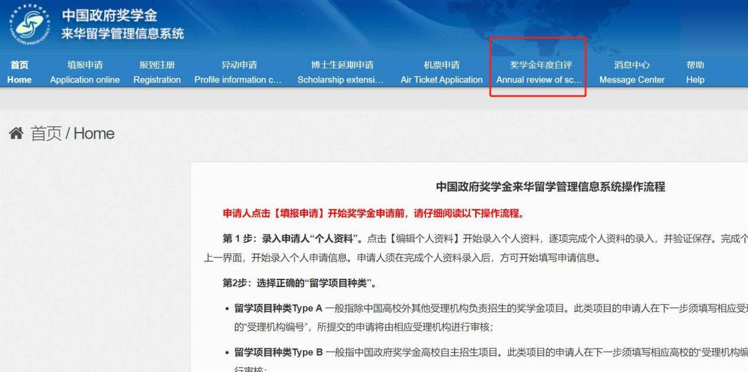

- 学生进入自评页面，根据要求填写相关内容，上传成绩单等附件信息。成绩单为上一自然年成绩，即2020-2021-2和2021-2022-1成绩。
Students enter the self-evaluation page, fill in the relevant content according to the requirements, upload the transcript and other attached materials.
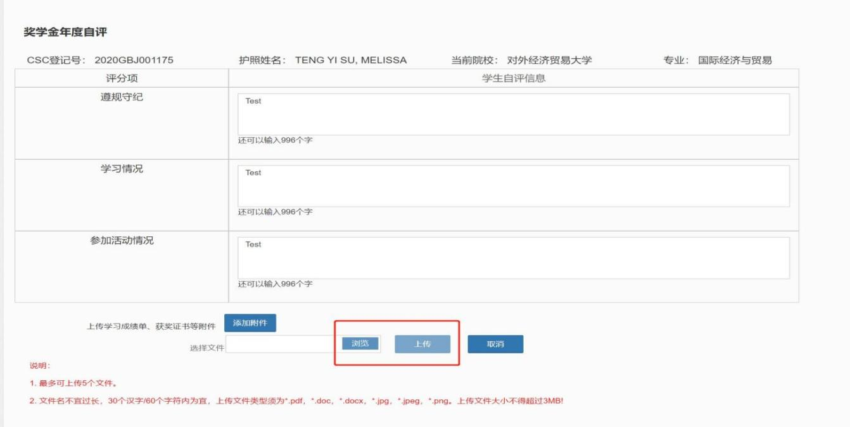
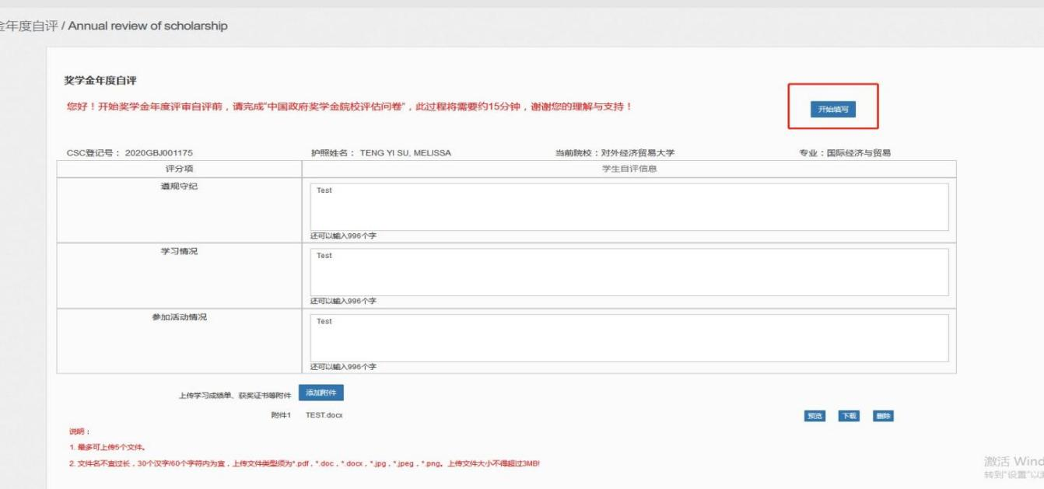
The transcript needs the grades of the previous calendar year which is 2020-2021-2 and 2021-2022-1.
- 填写完成并上传附件后，勾选承诺条款，点击提交。
After filling in and uploading the attachment, check the terms of commitment and click Submit.

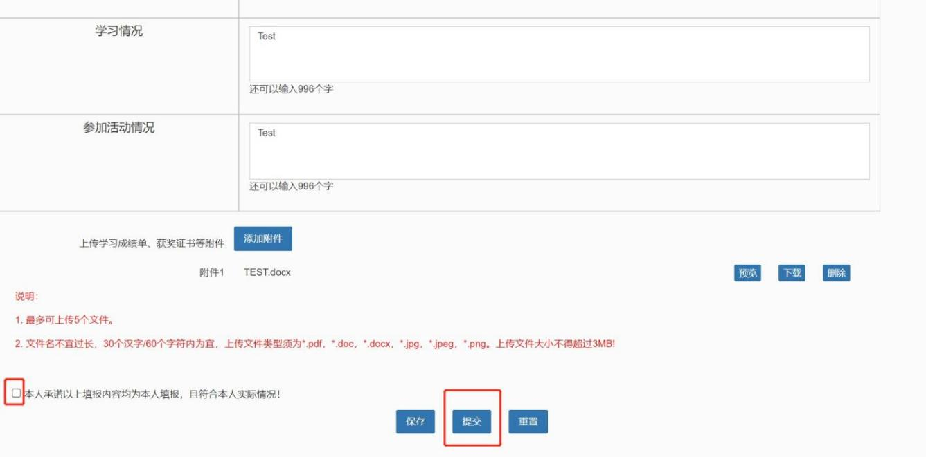
5.成绩单Transcripts
所有成绩单须中文版。Chinese version required for all.
本科生成绩单获取方法请参照相关网页Please refer to the relevant webpage for obtaining undergraduate transcripts：http://international.cpu.edu.cn/3c/87/c7345a146567/page.htm
硕士博士可找研究生院（行政楼703）打印成绩单，或登录研究生院系统，将完整成绩单截图，须包含要求学分、已修学分、未修学分。见图例。
Master's and PhD candidates shall print official transcripts with Graduate School (Room 703 Admin Building) or login Graduate School system to make a Screen Shot of the entire page (shall include required credits, credits attained and average score. See the following sample.
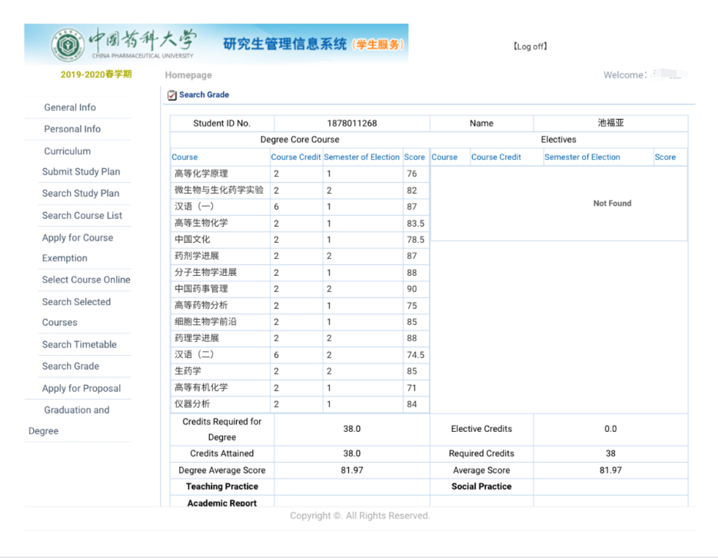研究生院信息系统生成成绩单示例
sample: transcripts generated by Graduate School online system

