My name is Chenai Theresa Boroma, 22 years of age. I’m a Zimbabwean lady studying International trade and economics at China Pharmaceutical University ,Jiangsu province, China.
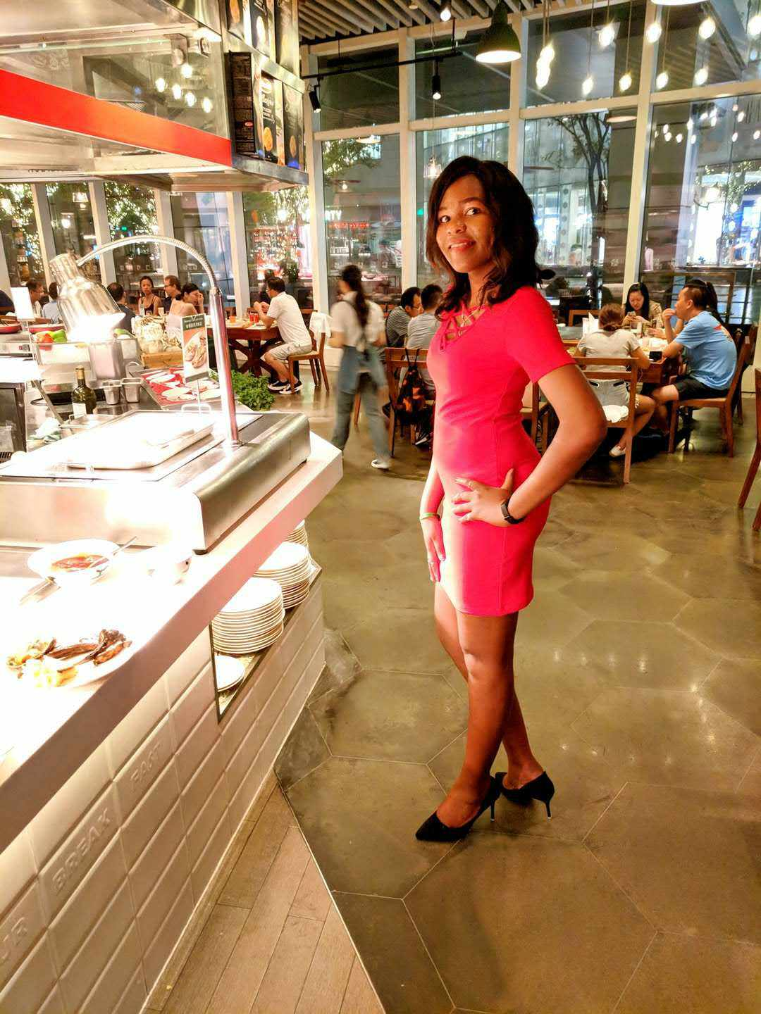
(A picture of myself)

Title: BETTER world in sight.

For long I was refrained , restrained and restricted from experiencing a better life. Caged in physical realism I was bound to not see ahead but my imagination always hinted me that a better life awaited me. I knew there was a better life but I didn’t know where or how to attain it. Life only changed the day I started to imagine what better life meant and I think that’s when some doors unlocked for me. From out of the blue I was fortunate enough to study in China, Jiangsu province.
Being far from home, torn between nostalgia and seeking greener pastures I struggled for days trying to fit myself in. It was a period of mental stress but i had to keep focusing on being a success.

To be honest, at first I suffered from anxiety and minor depression.I kept on thinking about my family members back home but with open arms the people from Jiangsu embraced me like one of their own and so my journey began.

During my first days in China my spirit was low. I’m grateful to the archaic well kept and preserved historical places in Jiangsu which played a role in my soul healing. A series of visits to Slender West Lake helped me rediscover who I am. It felt like nature and my spirit connected and that’s how I regained my mojo and hope for brighter days. The serene atmosphere at Xuanwu lake felt like an assurance from nature that all was going to be well with me. I felt reassured and rejuvenated. I had more reasons to be happy than to sulk even when I was far from home.

I find the Jiangsu people welcoming. Most of them that I have met have all been hospitable and I now consider Jiangsu as my second home. At school I even have Chinese friends and they help me tour around Jiangsu as well as teaching me the local language. During the weekends, my friends and I invest time in sight seeing around Jiangsu. We have gone to places like the Jiangsu Science and Technology museum, Ginkgo Lake Park ,to mention but a few.

This year, I also celebrated the Chinese National day with my friends at school and I was jovial to be a part of such a historical event.
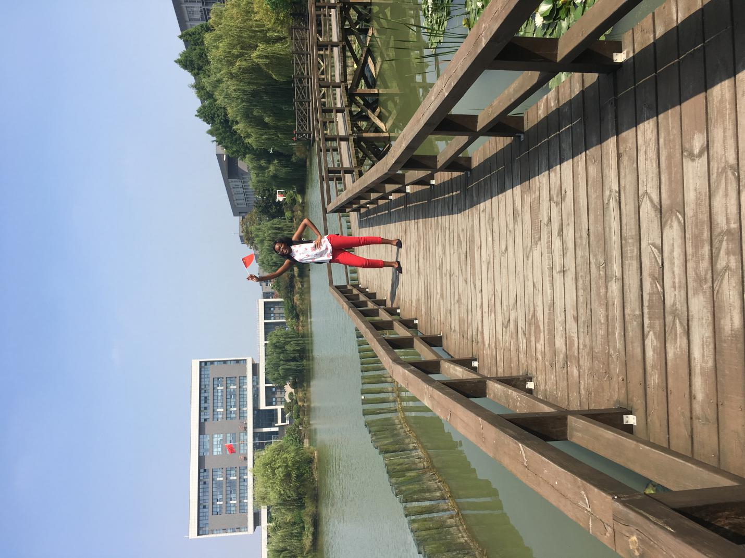
(Picture of myself on the National Day.)

What amazed me the most in Jiangsu was the affordable and efficient transport system in Jiangsu. The bullet trains, metro, taxis and buses all in service for my comfort. Back home, I didn’t know all that because my country has fuel shortages and is still developing. Even the value of the Chinese Yuan left me in awe because I had never seen such a currency which is not easily affected by inflation. I vividly remember the day I walked into a supermarket at Longmiandadao, I was in cloud nine. All the necessary commodities were there at very affordable prices. I couldn’t contain myself and I found myself buying so much. Coming from a country like Zimbabwe where there are sky rocketing prices and the economy at the verge of collapsing I find the Chinese Yuan amazing.

Another thing that me so excites me is the state of the art technology in Jiangsu. For example the facial recognition system all over the place make me feel secure. From street cameras, shop cameras or even corridor cameras at my school make me feel like someone is watching over me. I also like the effective Elema system of food delivery which is there for my convenience.

At first my mother was so worried about sending me off to a foreign land where no one will watch out for me but now she’s happy after I told her about the intact moral fabric in Jiangsu which complies with my country’s values as well , for example, respecting elders and importance of family. I have Ms Zhang Chen from school to tell all the problems I face as an international student and I’ve also grown fond of Ms Miao who is my Chinese teacher because she’s sweet and calm.My mother is relieved now because I have other people to tell my concerns.

My stay in Jiangsu so far has been nothing but a dream come true. The better life I yearned for is insight now. They say “home is where your heart is” and right now my heart is in Jiangsu and it is my home.
The end

Name:Chenai Theresa Boroma
Student number: 2620190126
Gender:female
Age: 22
Nationality: Zimbabwe
Major: international trade and economics (first year)
School: China Pharmaceutical University

