中国药科大学核酸检测信息系统
系统操作指引
CPU nucleic acid detection information system guide.

江苏省疾病预防控制中心
2021年2月

登陆系统
Step 1: Use Wechat to scan the QR code
教职工及学生和登记/装箱工作人员使用手机微信扫描下方对应二维码登录系统，同时保存二维码以便结果查询和重新登录。

个人注册registration
Step 2: Click “身份证” then select the second option “护照”

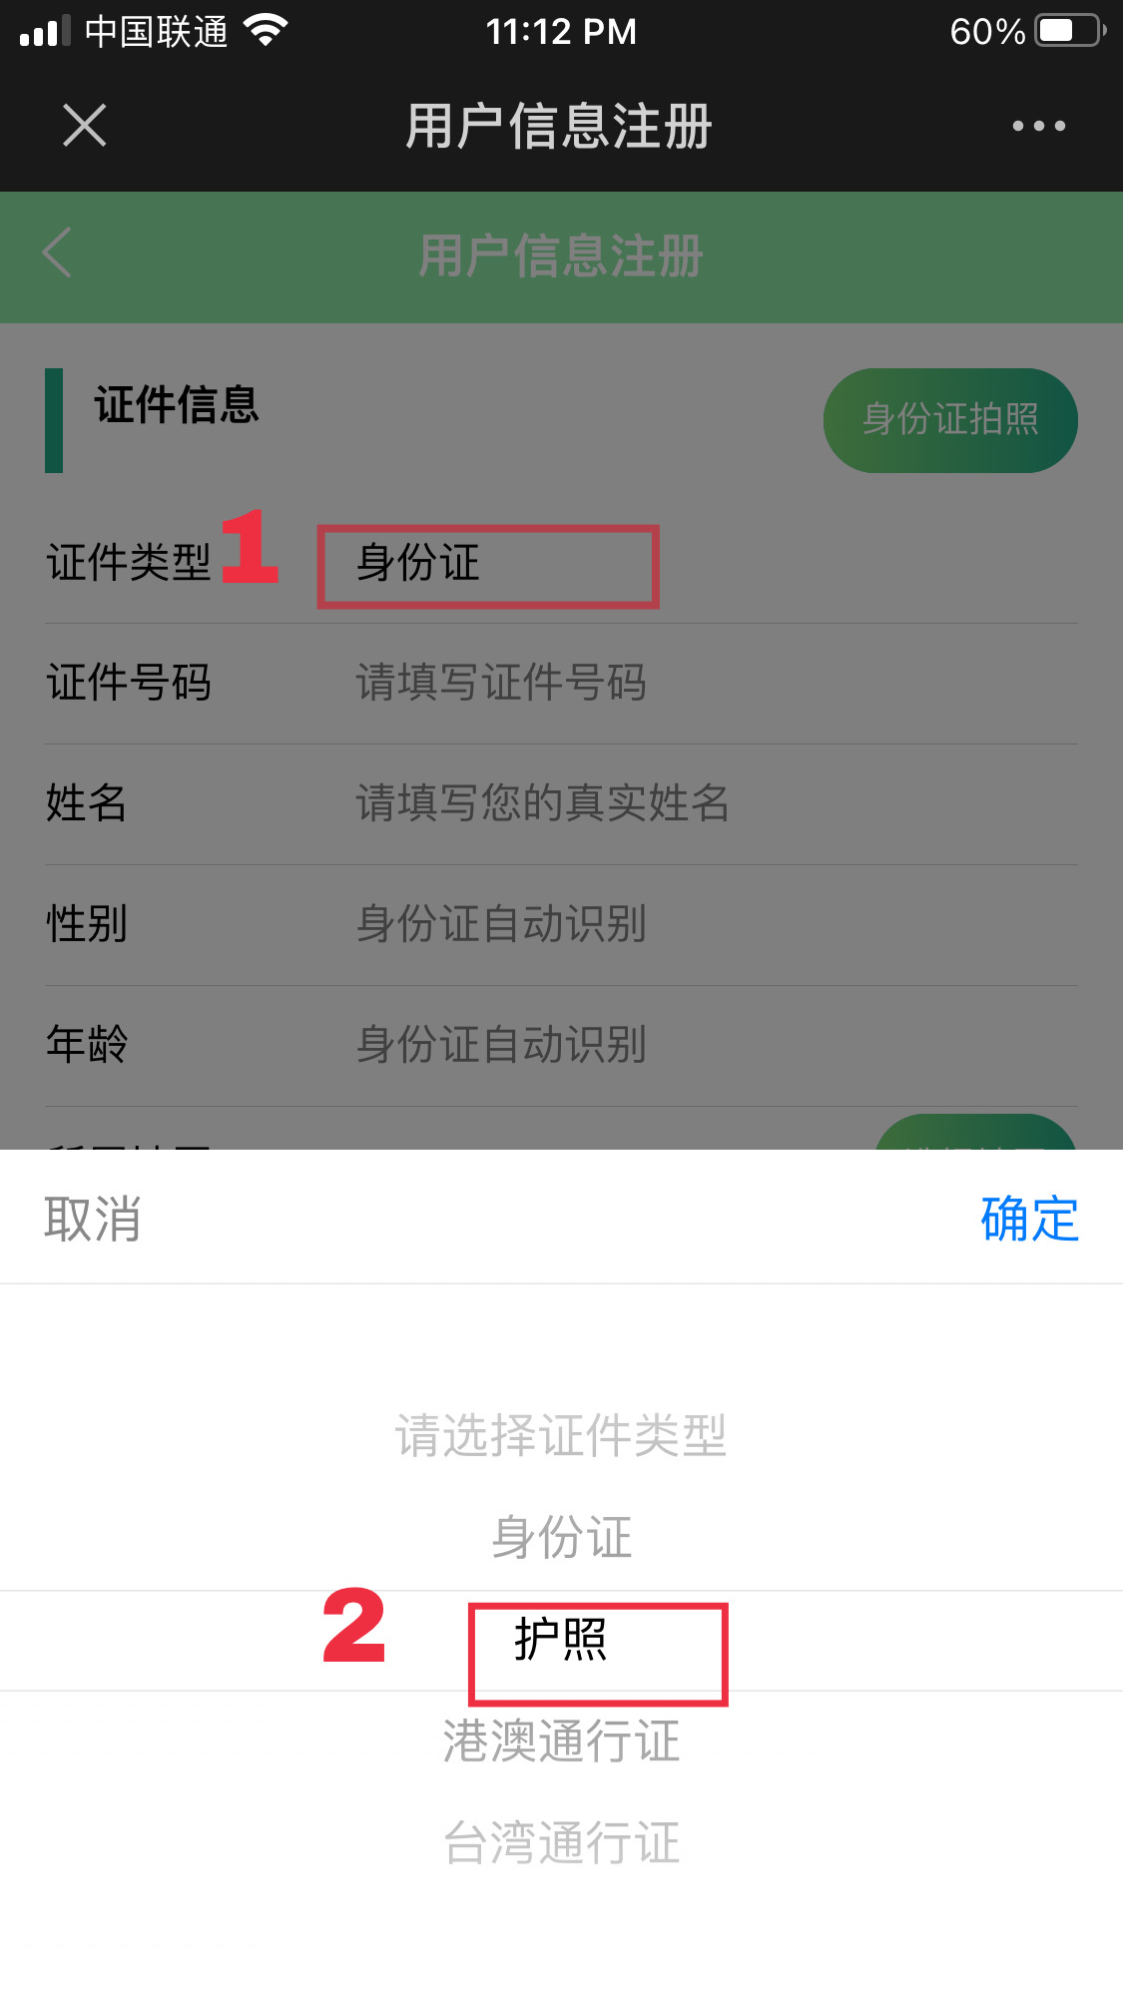

Step 3: Write your personal information.
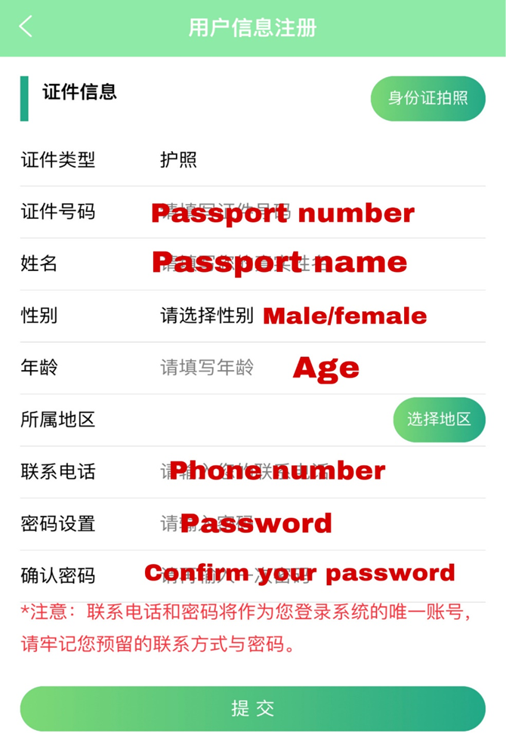
Step 4: Select your location.If you live in Jiangning campus, please select 南京市江宁区，if you live in XWM campus, pls select 南京市鼓楼区。
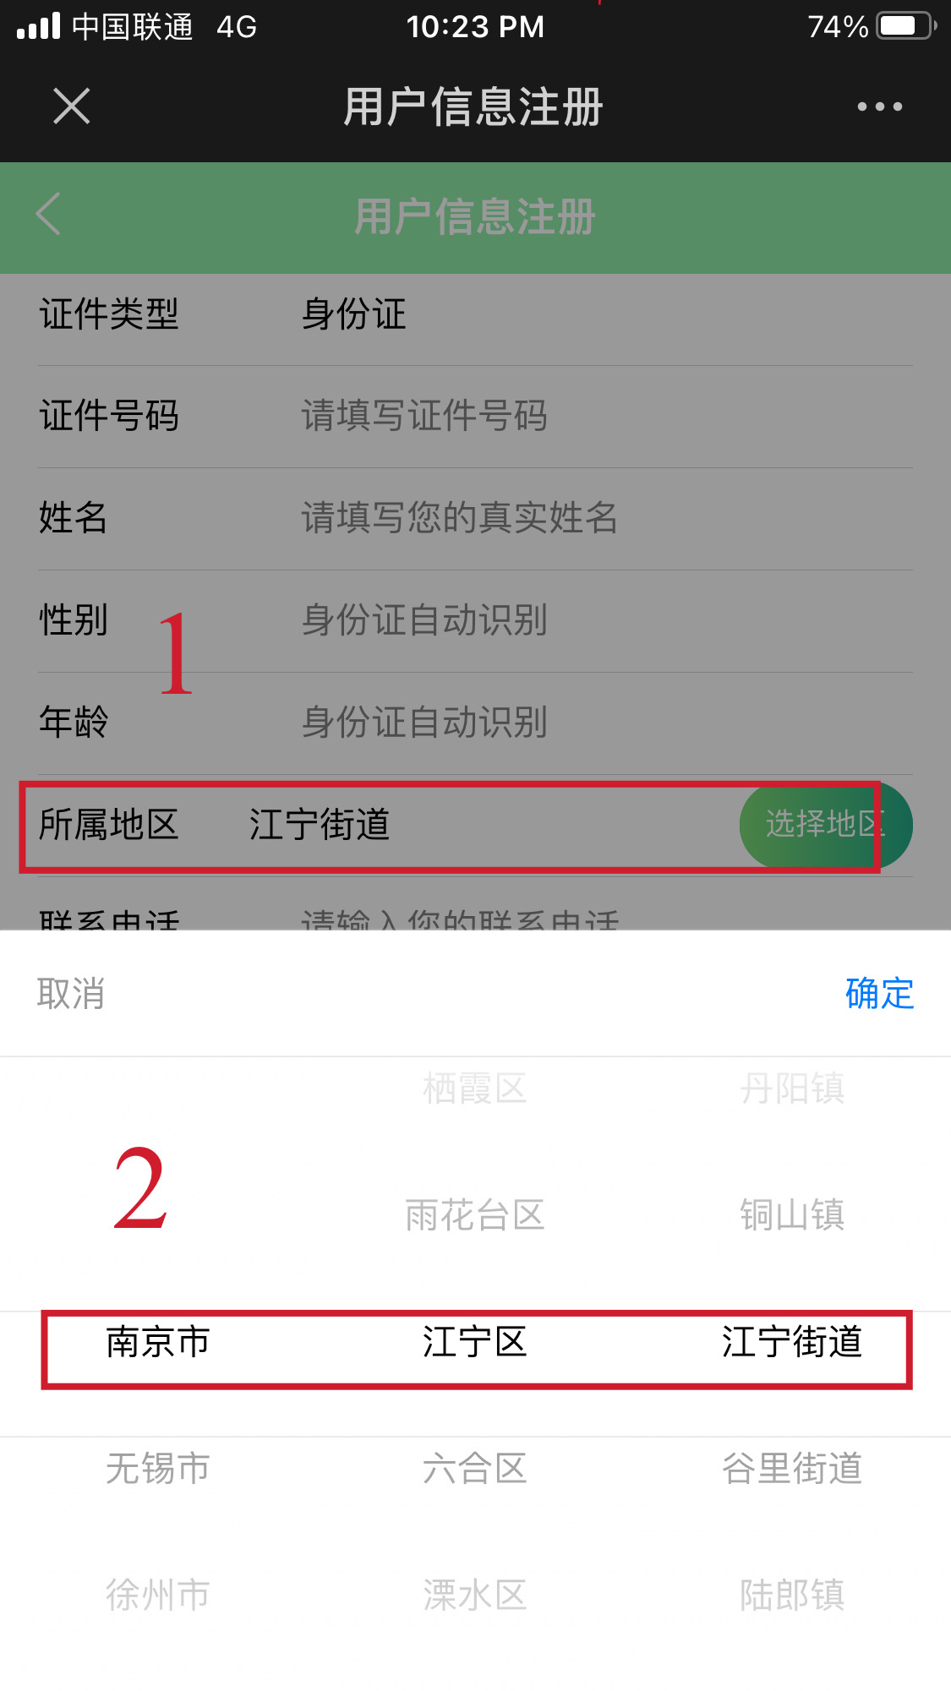
Step 5: After completing all the steps, click “提交” to submit.
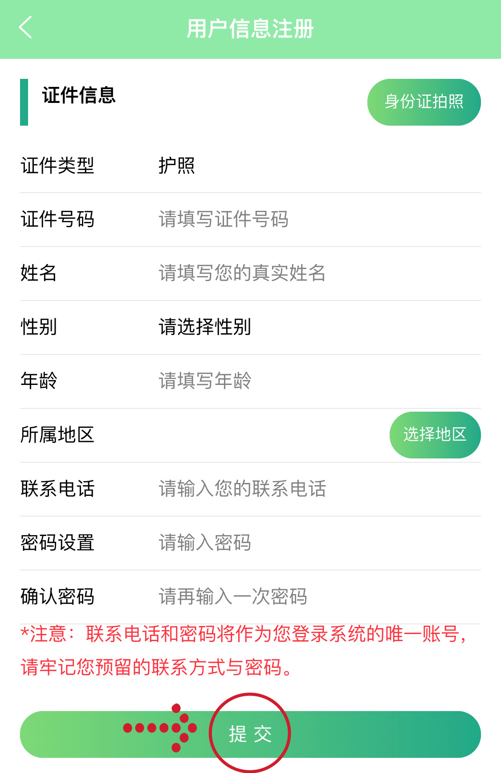
Step 6: After submitting, the next page will appear。 Then click “检测预约“。
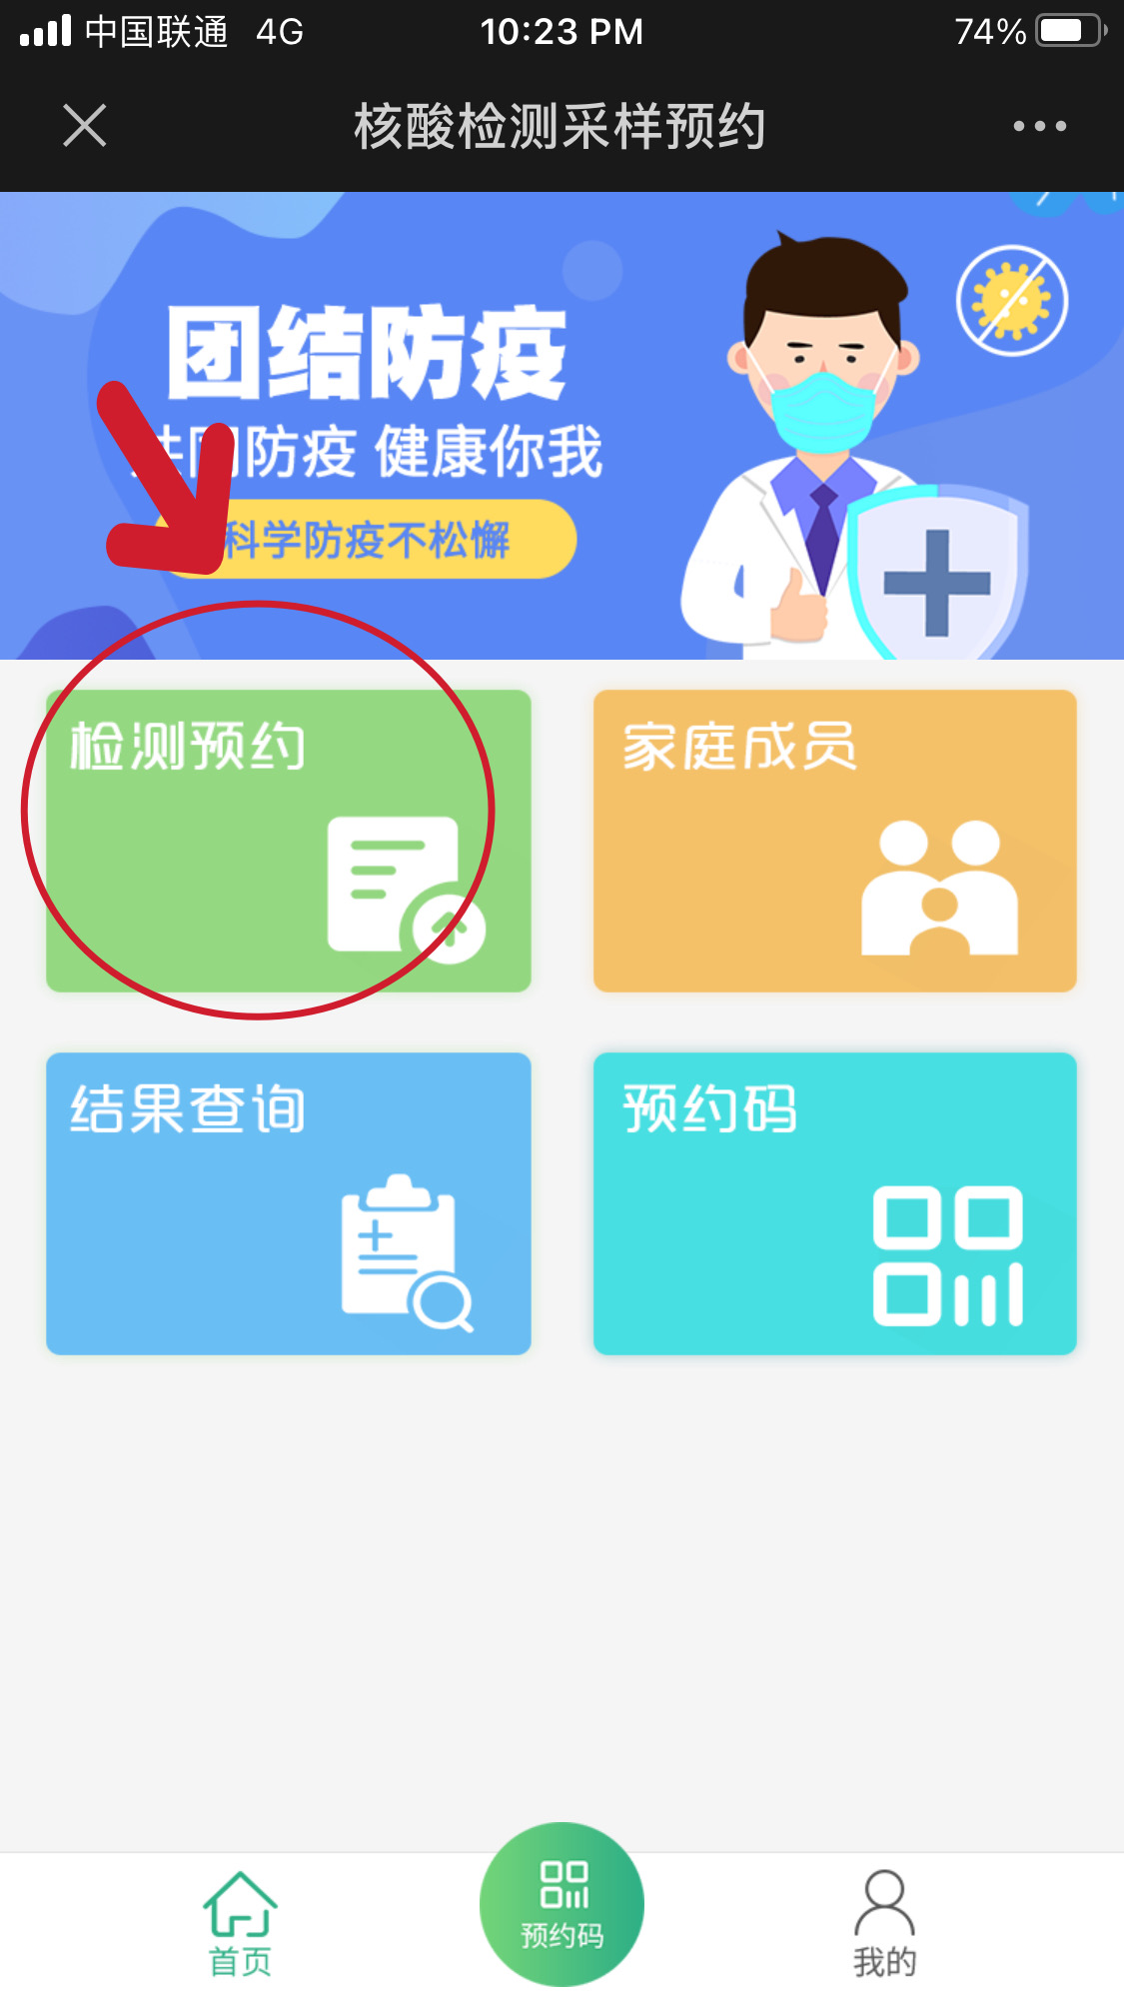Step 7：Click “新建检测预约”

Step 8：Write your passport name and select the right address as seen in the picture。If you live in Jiangning campus, please select 南京市江宁区，if you live in XWM campus, pls select 南京市鼓楼区。
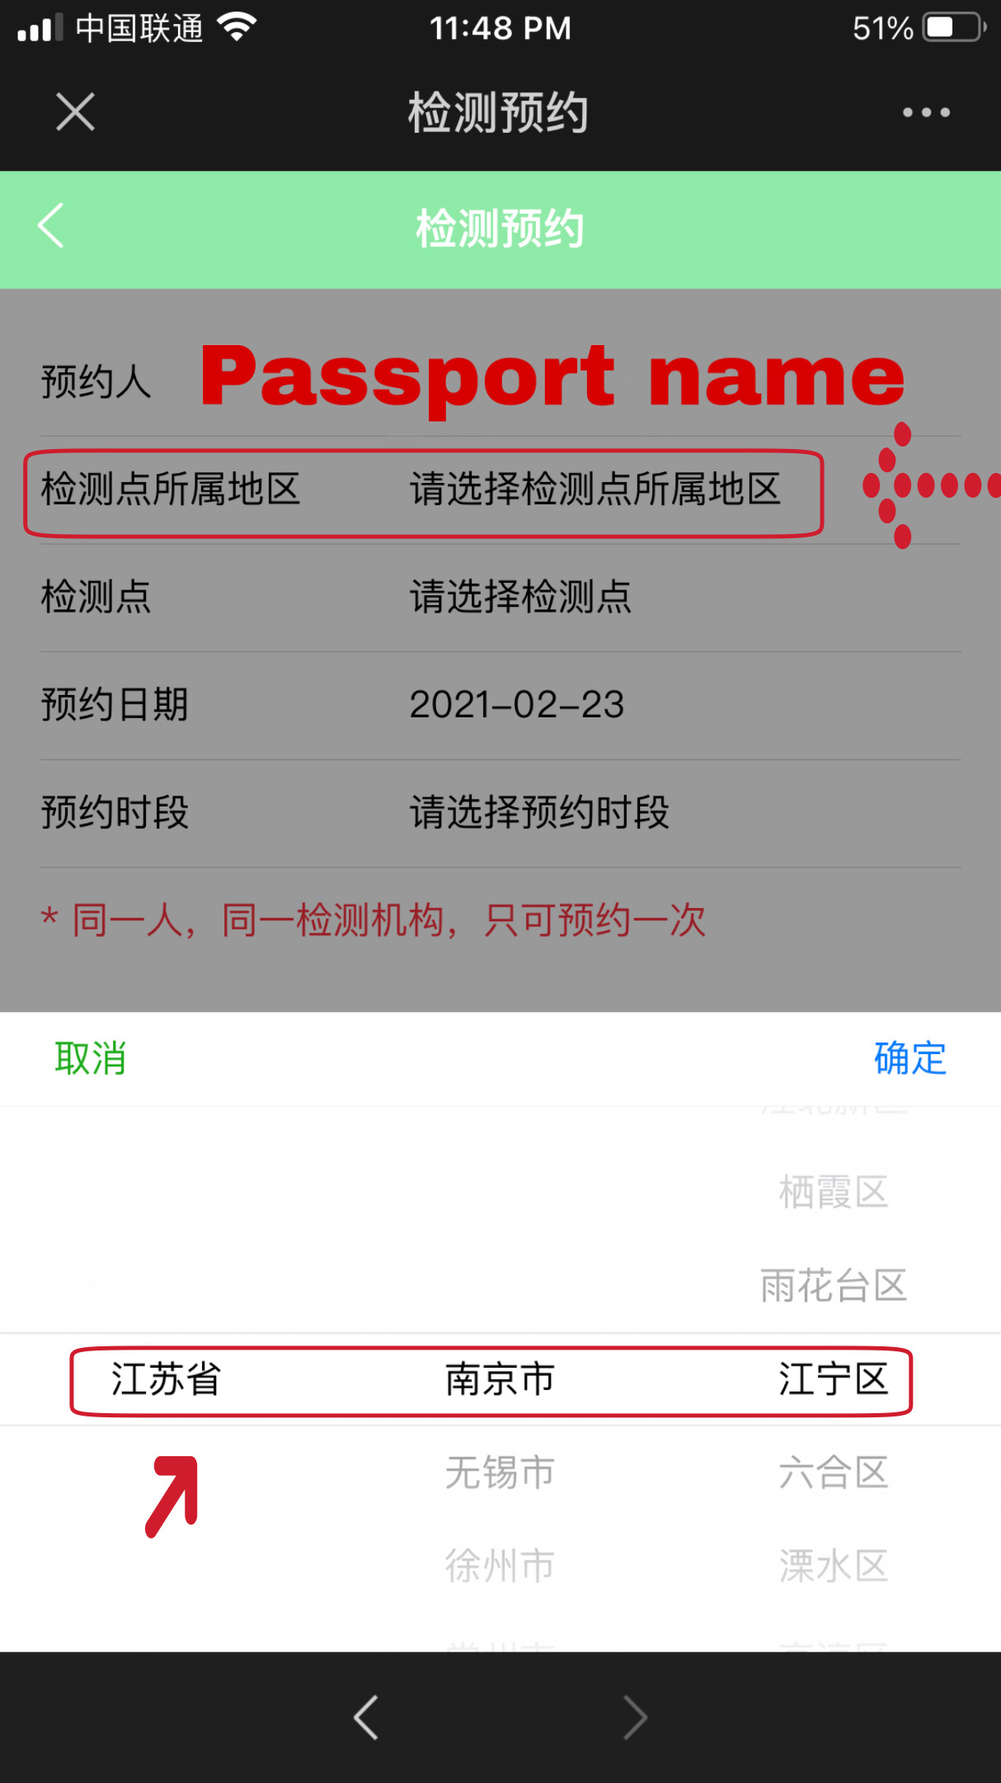

Step 9: for the testing location, jiangning campus students need to selcet “中国药科大学(江宁)”,XWM campus students need to select 药科大学（玄武门校区）.
药大（江宁校区）务必选择江宁区-药科大学（江宁），选择采样
药科大学（玄武门校区）选择务必选择鼓楼区，选择准确采样时间。
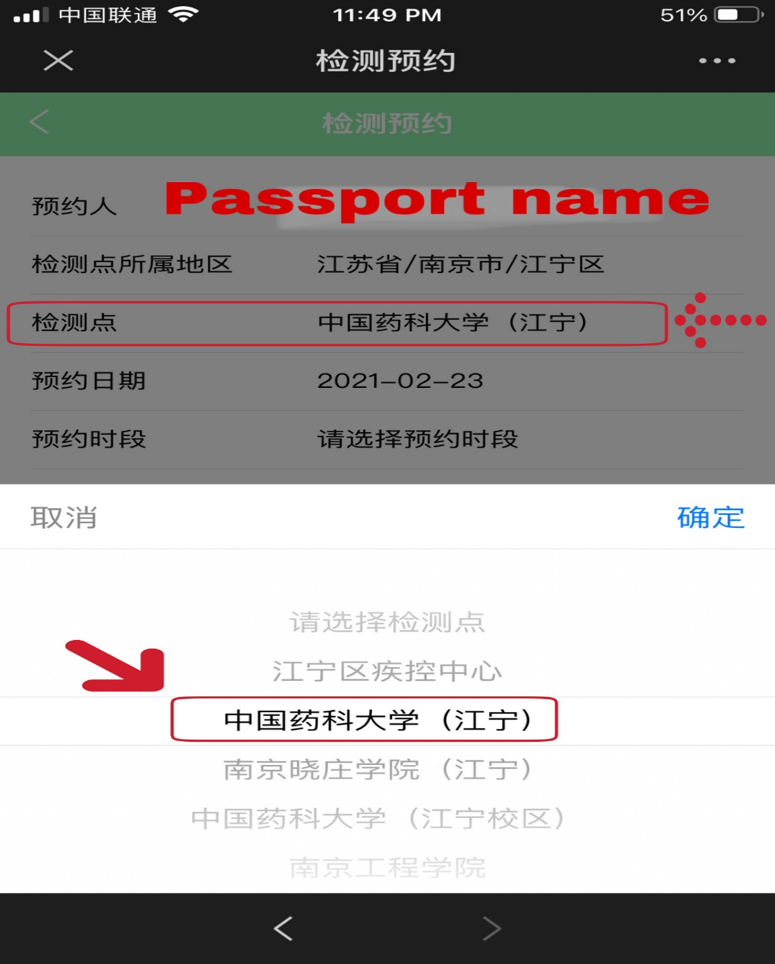

Step 10: select the appointment date(the date must be Feb 27 or 28) then select your appointment time “上午（morning）or下午(afternoon）”.
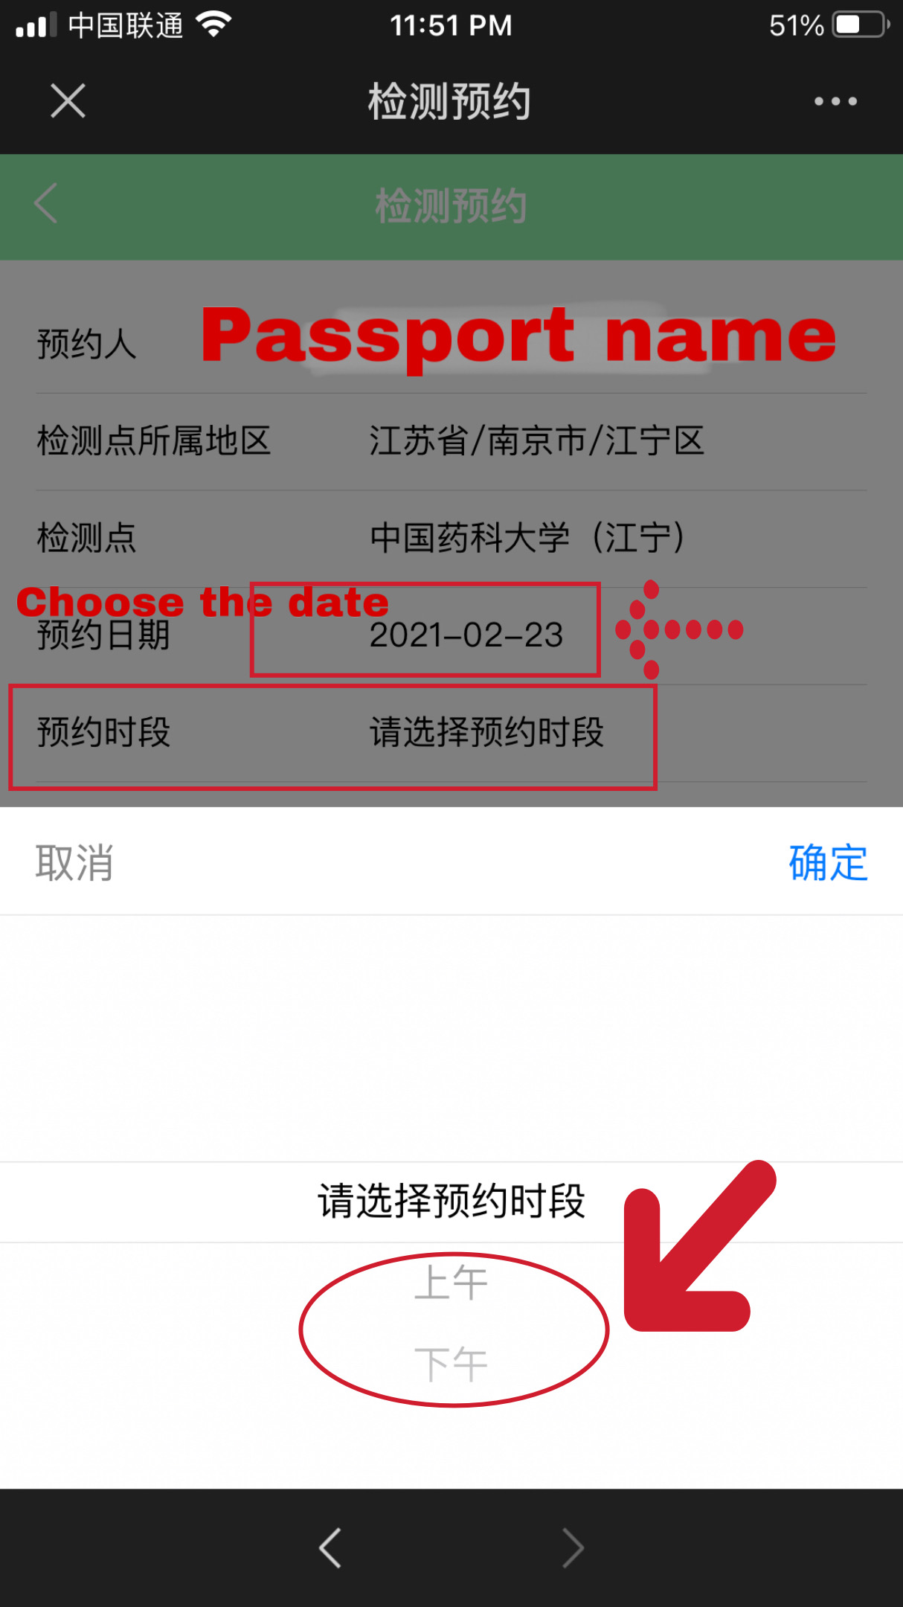
Step 11: Click “确认预约” to submit
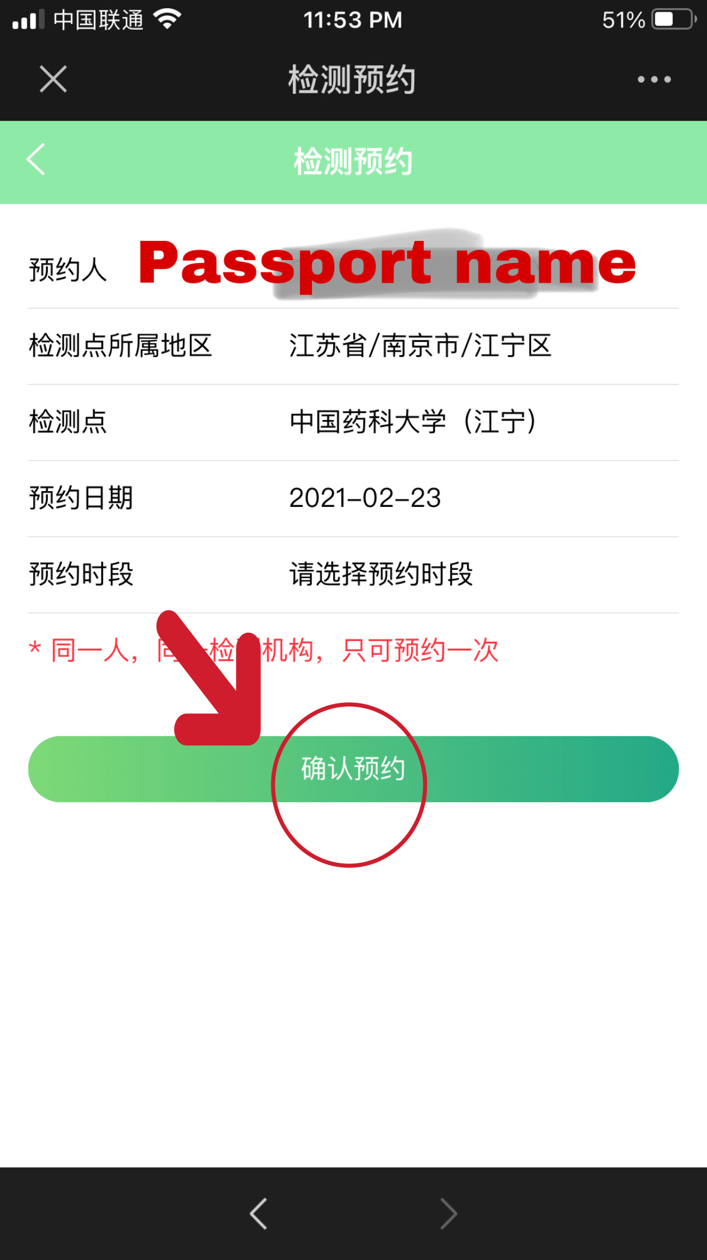

Step 12: If you see this page then your application was successful.
*SUCCESSFUL APPLICATION*
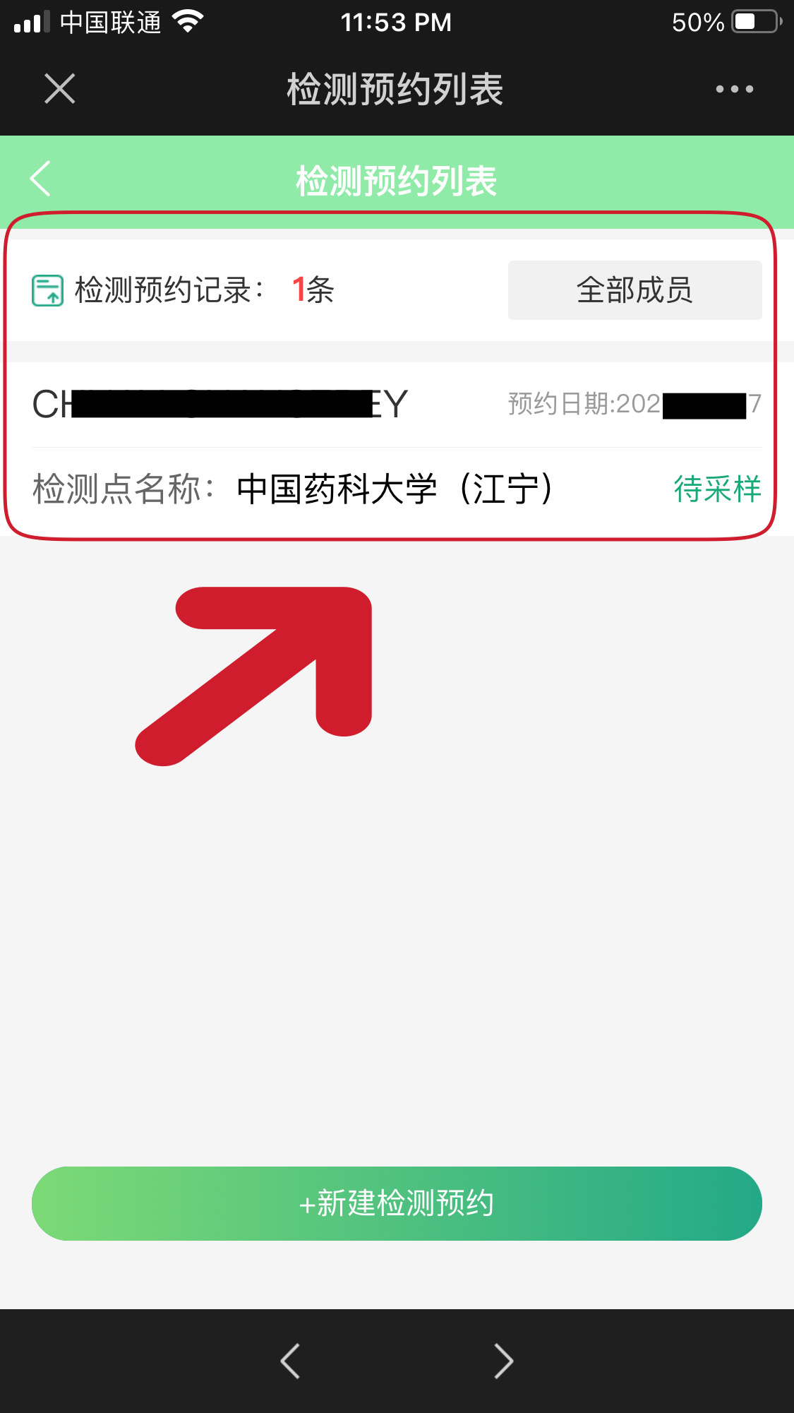
采样前务必准备好打开手机出示预约码并带好校园卡及护照。 When you arrive, open the mobile phone and show the code.please also bring your passport and student ID card with you for the test.

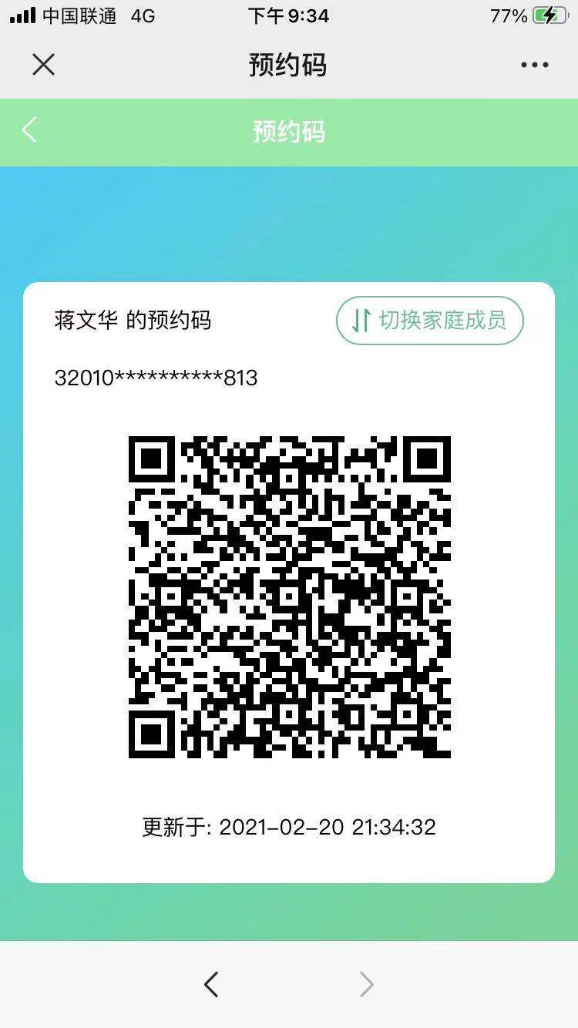

结果查询
Click “结果查询” to check your result.
